**NAME: Hithesh Shanmugam**

**Code: CSC 480**

**ID:2068266**

**YouTube link:** [**https://youtu.be/NaaAw1LTugo**](https://youtu.be/NaaAw1LTugo)

**DOTS and BOXES:**

After playing the game several time I could tell what values of the plys and number of boards in the game is difficult for the AI and the human who is playing with the AI.

Plys- The depth of the tree.

**Evaluation:**

I used the time tool to calculate the time taken for the AI to calculate the move the AI should make after the user plays. I have also added different points for different boxes. I have played the game for 2 plys and 2 as the number of boards. The time taken for the AI to make every move was less than one second. And for the 4 plys and 2 as the number of boards used, here the time taken for the initial move of the AI was nearly 2 seconds and for the next move it was nearly 1 second and it was decreasing for every other moves. For 5 plys and 2 as the number of boards used the time taken for the first move to calculate was nearly 13 seconds and the next moves were decreasing as the same for the 4 plys. From this what I could say is that as the number of plys increase for the same number of boards used the AI takes longer to calculate its first few moves. The reason why it takes longer for the first few moves only because the AI have only few more spaces to play as it reaches to the end and it might have already pruned the data.

I have also played the game for 3plys for 3 and 4 number of boards in the game and I can also say that the time taken for the AI to take does not depend on just the plys but also the number of boards used in the game. The first move in 3ply 3 number of boards is nearly 2.75 seconds and for 3ply 4 number of boards is nearly 15.5 seconds. But the AI takes only long time for the first few steps. As in humans’ point of view the initial steps are easier to calculate but as it goes to the end the computer calculates the pick fast with the weighted values which is harder in case of humans to predict the values and try to win the computer. The pictures following would give the details of the calculation.

From my understanding from this code what I could tell is that when the size of the board increases the complexity increases for both the AI and the human. With the ply increasing it makes it harder for the AI to choose the move at the beginning and at the end it makes easier for AI but harder for the human.

How much deeper the AI explores the tree using alpha-beta pruning?

The drawback of the minmax algorithm is that it goes through each and every node of the tree whereas the alpha-beta pruning doesn’t have to go through every node. Alpha-beta pruning can be applied to any depth of the tree. The exploring of AI of the tree depends on the depth we choose.

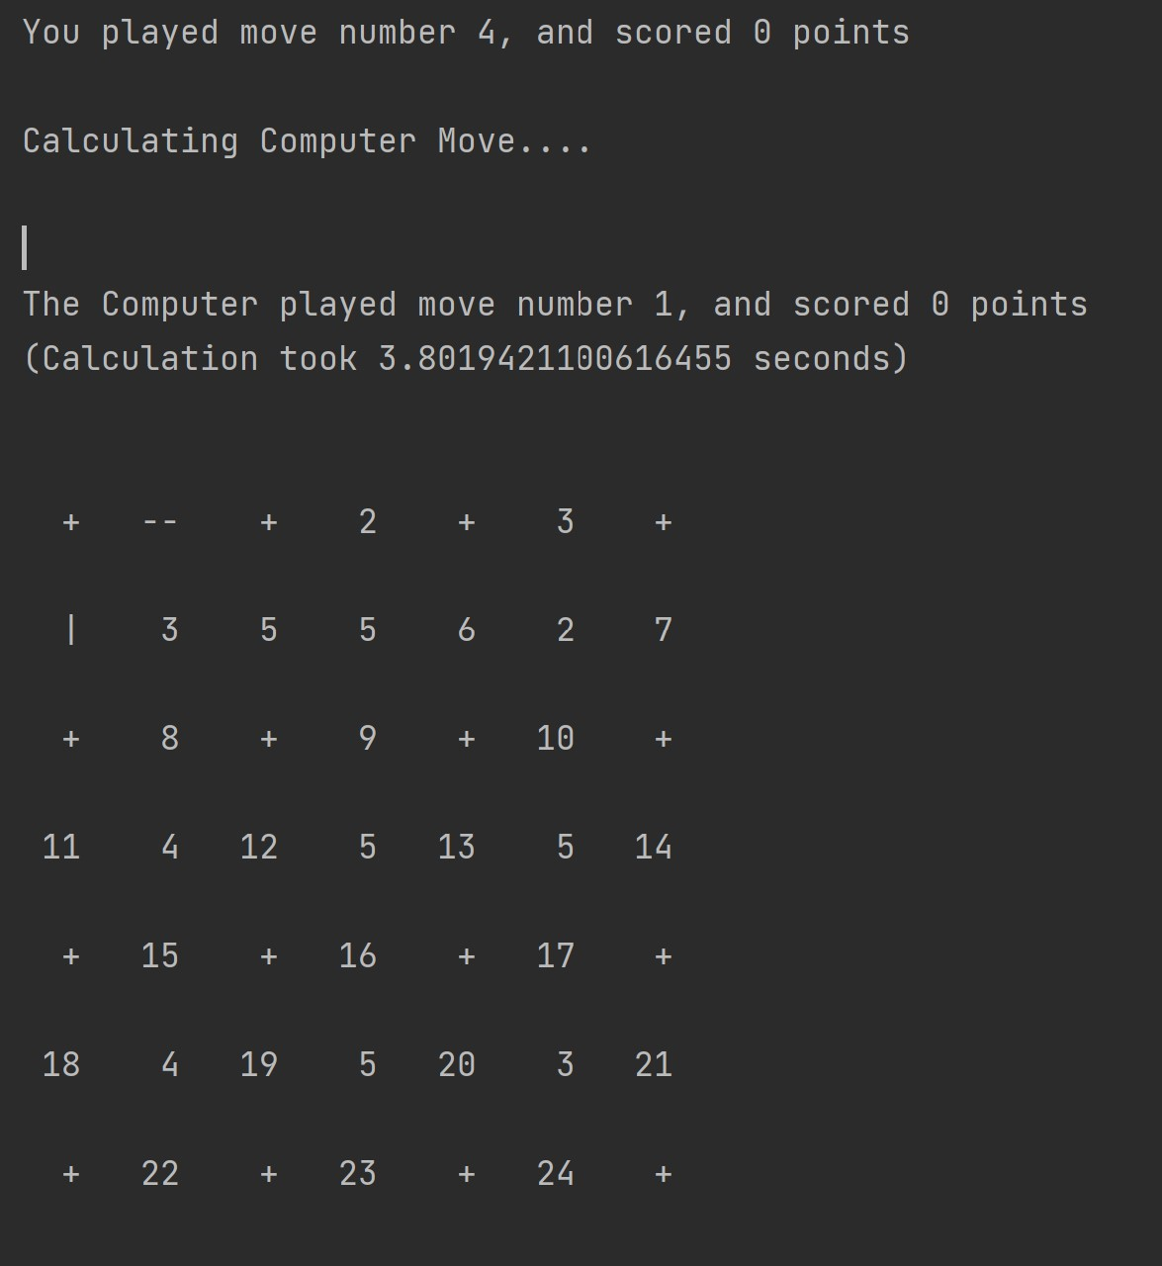

**3-plys, 3 number of boards**

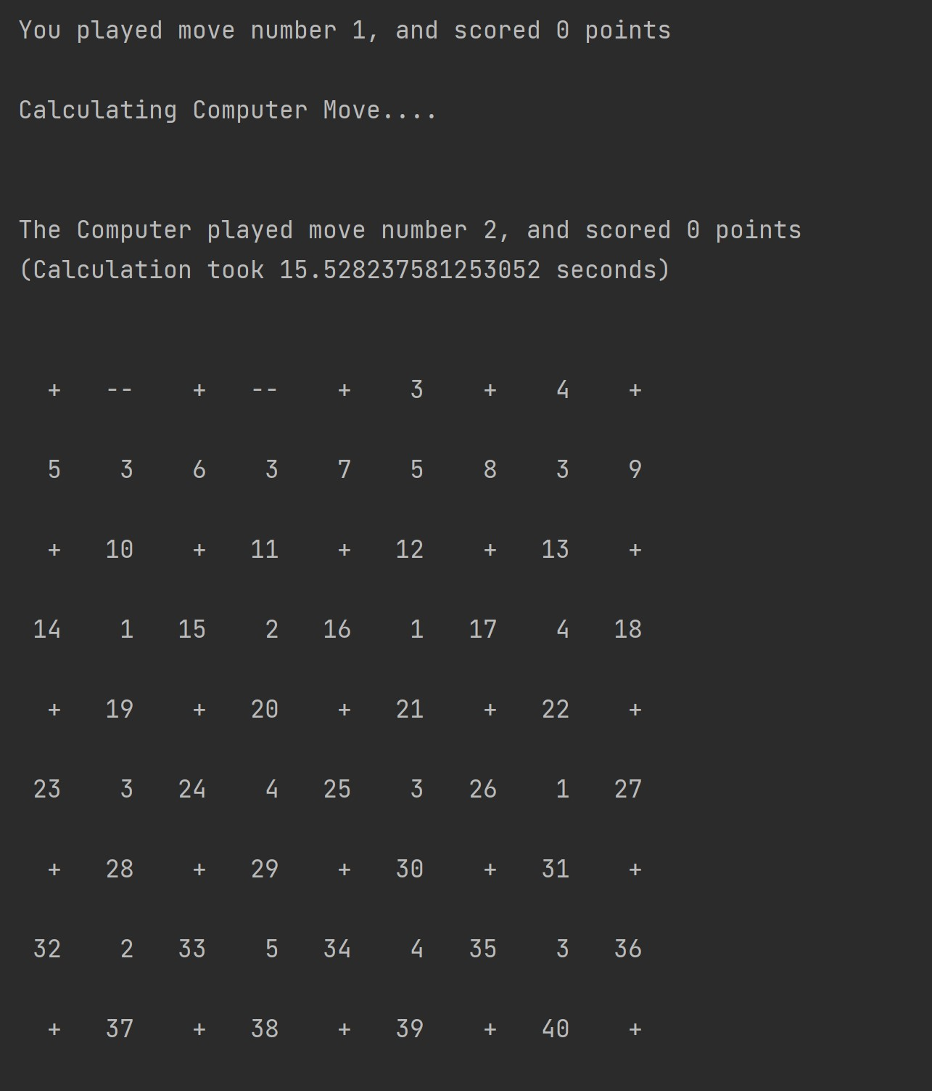

**3-plys, 4 Number of boards.**

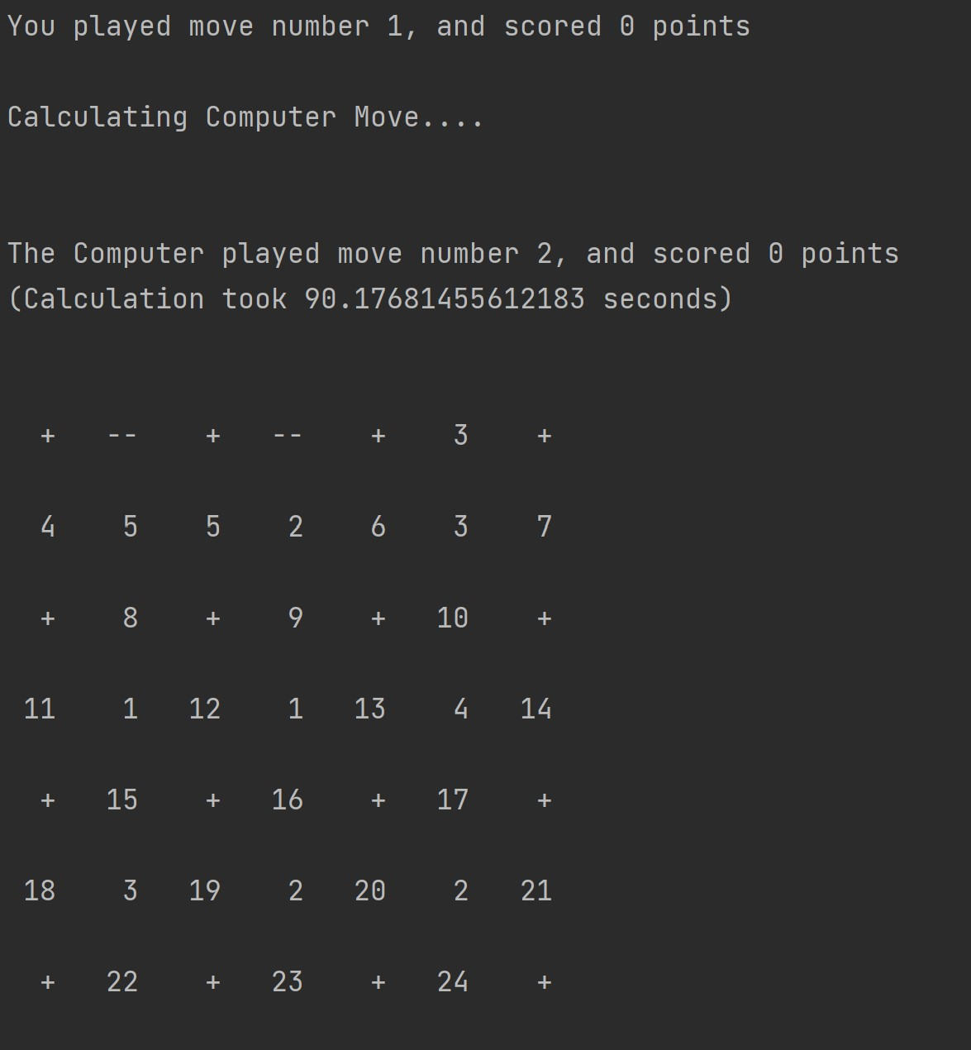

**4-plys, 3 number of boards**

Which is harder for the computer to predict?

As we can see from the screenshots of the first steps of the computer, Increasing the number of plys for the same size of board makes it harder for computer rather than the same ply and increased size of the board.